Assignment Two: Experimental Design

Yi Chen

Teachers College, Columbia University

Research Methods in Social Psychology

Assignment Two

*Problem 1*

I will use **pretest-posttest two-group design**. In the plot below, the “O” represents the observation, “X” represents the group (i.e., treatment or control group), “R” is the participants in this experiment.

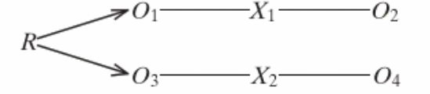

There will be a $2×2$ factorial design in this experiment (including one independent variable and one moderator variable). We assume that there will have an interactive effect between the independent variable and moderator variable. This contingency table allows us to measure these effects. The factorial design is shown in the Table 1.

|  |  |  |
| --- | --- | --- |
| Present of child’s parent | Child’s Gender | |
| Male | Female |
| Present | M, P | F, P |
| Not present | M, NP | F, NP |

The reason that I use this method is because:

* It provides a check on the randomization (e.g., whether there exist systematical differences between the groups) before the treatment;
* It provides a more sensitive test of the effects of the treatment by letting participants sever as their own comparison. I can compare the difference between pretest and posttest (e.g., O2 – O1).

The questions that may be raised by the pretest-posttest two-group design are:

* It can sensitize participants to the purpose of the experiment and bias their posttest scores. If the pretesting affects the experimental groups differently, it becomes a threat to the internal validity. Because the treatment alone cannot fully explain the difference in the difference in the posttest.
* Since the moderator in this experiment is gender, we cannot randomly assign the gender. There will has selection bias for the internal validity.

*Problem 2*

**Independent variable is the presence status of primary caregiver**. I will pick one of the parents for each child, who spend more time with their children and share more responsibility of teaching the child at home. It is binary (two levels) observed variable. For each experimental object $i$, this variable can be indicated as:

$${presence}_{i}=\left\{\begin{aligned}1 \\ 0\end{aligned}\right.\begin{matrix},presence of mother/father \\ , absence of mother/father\end{matrix}$$

**The moderator is the gender of the child**. The reason that I pick this variable as moderator is because I will to see whether the gender difference at very young age will impact children’s dependence on their parents, and their performance.

$${Gender}_{i}=\left\{\begin{aligned}1 \\ 0\end{aligned}\right.\begin{matrix},Male \\ , Female\end{matrix}$$

**The dependent variable will be the overall performance of the task**. According to the design of the pretest-posttest experiment. The difference between two testing scores will be used for main dependent variable. Bigger value of performance score indicates bigger improvement of the children and higher performance. There is a natural tendency that children will perform better in the posttest since they accumulate more skill during the practice in the pretest.

$${performance}_{i}={pasttest_score}_{i}- {pretest_score}_{i}$$

*Figure 3*. Research Framework

*Problem 3*

My hypotheses are:

1. For male children, their score will decrease slowly when their main caregiver present during the test than when their main caregiver does not present.
2. For female children, their score will improve quickly when their main caregiver present during the test than when their main caregiver does not present.

*Problem 4*

The participants of this experiment are young children, who are aged from 4 to 5 years old. I focus on the young children because generally there is less systematical difference between these children at the similar age. As they growing up, children’s difference usually becoming more obvious because of education and social background. And more uncontrollable factors will bring into the experiment.

In this experiment, I will invite 120 children. Among these children, 60 of them will be male and 60 will be female. These children will be aged from 4 to 5. And they are all coming from Long Island New York city, since I want to reduce the influence from social economics difference. Among each gender, half of the children (30) will be assigned into the control group (absent of parents), and half will be assigned into the treatment group (present of parents). This random assignment will get rid of the systematical impact from other factors (e.g., race). 30 participants in each factorial group usually is big enough for statistical analysis. For example, the likelihood ratio test or Pearson chi-square test. These methods rely on the big sample to ensure the statistics will converge to the chi-square distribution. Then, we can do hypothesis testing (e.g., independence testing) for the data the contingency table.

The environment will be hold in a conventional kindergarten classroom (to reduce the notice of unfamiliar environment). All children will take two tests (pretest and posttest) individually. During the test, there will be two experimenters (one for interact and guide the child through the test, one for taking the records and notes). Since every child is tested individually, there is no interpretation from other children. There will be a 10 mins rest between two tests.

At the beginning of the test, the experimenter will ask what is the toy each participant (children) favorite. Then, participants will be told that if they perform well during the test, they will get their favorite toy as reword. Thus, all the children are motivated to pursue higher score every time. This will help to reduce the noise from motivation.

*Problem 5*

The test is a jigsaw puzzle game. Each jigsaw has (4x4) 16 bits. If the whole jigsaw is complete it will score as 16 points. Otherwise, they score will be the number of bits they put correctly. Experimenter will randomly pick one jigsaw to them. And once they finished, they will be given a new jigsaw. The duration time for the testing is 5 mins.

The children in the control group will attend both pretest and posttest by themselves. While, the children in the treatment group will attend both tests with their parents. The children and their parents will be noticed that parent cannot help the children to finish the test in any way. During the test, parents are asked to sit beside the children and watch the whole test process without making any notice or interacting with their children. The parents cannot provide feedbacks to their children during the rest. During the rest time, children from both control and treatment group will play toys in the classroom without their parents.

The information of children and parent (in control group or treatment group) will be recorded by the experimenter. And information will be double checked before and after the test. The experimenter will directly score the test.

*Problem 6*:

the result of could be visualized as Figure 3. I think the female will have an insignificant advantage when the main caregiver does not present, compared with male. They are easier to focus on the test and keep claim. With their parents sitting in the classroom, male children will have lower score. This is because: (1) they want to prove that they are smart and want to win the toy, this wish is too strong and become a pressure. (2) once they face the problem, they want to ask their parents for help while it is not allowed which give them a lot of psychological interpretation. For male children, their score will decrease slowly when their main caregiver present during the test than when their main caregiver does not present. For female children, their score will improve quickly when their main caregiver present during the test than when their main caregiver does not present.

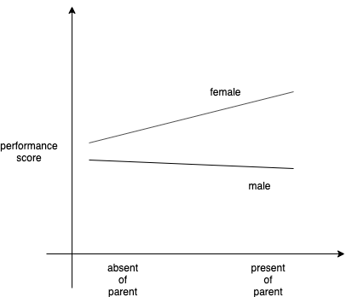

*Figure 3*. Result visualization